# Core

## Basics

What is a strongly typed programming language?

In a strongly typed language compiler ensure type correctness, for example, you **can not store the number in String or vice-versa**.

Java is a strongly typed language, that's why you have different data types Ex int, float, String, char, boolean etc.

On the other hand, weakly typed language don't enforce type checking at compile time and they tree values based upon context. **Python and Perl** are two popular example of weakly typed programming language, where you can store a numeric string in number type.

Can you describe three different kinds of testing that might be performed?

**Unit Testing, Integration Testing and Smoke Testing**.

* **Unit testing** is used to test individual units to verify whether they are working as expected
* **Integration Testing** is done to verify whether individually tested module can work together or not
* **Smoke Testing** is a way to test whether most common functionality of software is working properly or not e.g. in a flight booking website, you should be able to book, cancel or change flights.

What is the difference between iteration and recursion? ([detailed answer](http://javarevisited.blogspot.sg/2012/12/recursion-in-java-with-example-programming.html))

* **Iteration** uses a loop to perform the same step again and again.
* **Recursion** calls the same method itself to do the repetitive task

What is test-driven development?

Test driven is one of the popular development methodologies in which tests are written before writing any function code. In fact, test drives the structure of your program. Purists never wrote a single line of application code without writing a test for that. It greatly improve code quality and often attributed as a quality of rockstar developers.

How do you find a running Java process on UNIX?

You can use the combination of **'ps' and 'grep'** command to find any process running on UNIX machine. ps -e will list every process i.e. process from all user not just you and  ps -f will give you full details including PID, which will be required if you want to investigate more or would like to kill this process using kill command.

ps -ef | grep "java"

Difference between WeakReference vs SoftReference vs PhantomReference vs Strong reference in Garbage Collection?

there are four kind of reference in Java :

1. Strong reference
2. Weak Reference
3. Soft Reference
4. Phantom Reference

## Collections

Difference between Stable and Unstable Sorting Algorithm - MergeSort vs QuickSort

Merge Sort Algorithm

Merge Sort follows the rule of **Divide and Conquer** to sort a given set of numbers/elements, recursively, hence consuming less time.

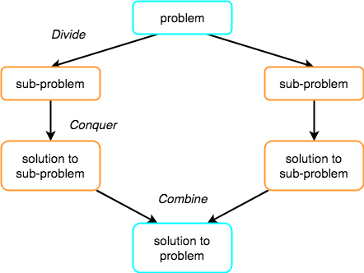Divide and Conquer

If we can break a single big problem into smaller sub-problems, solve the smaller sub-problems and combine their solutions to find the solution for the original big problem, it becomes easier to solve the whole problem.

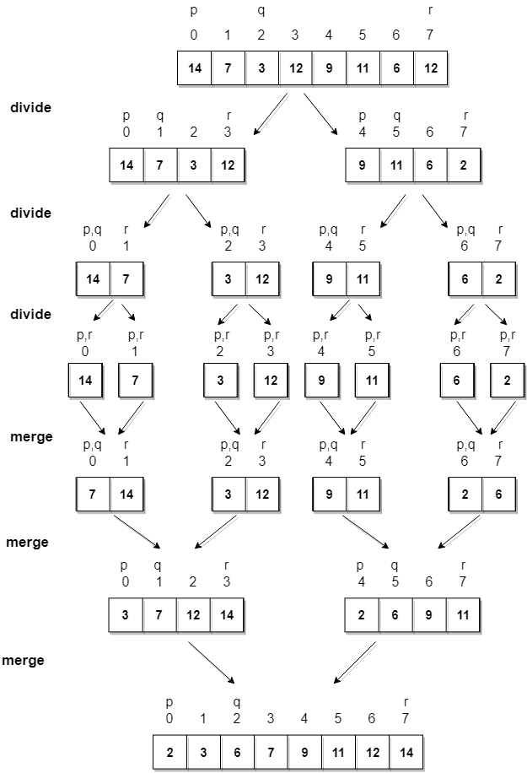

**Algorithm**

Merge sort keeps on dividing the list into equal halves until it can no more be divided. By definition, if it is only one element in the list, it is sorted. Then, merge sort combines the smaller sorted lists keeping the new list sorted too.

**Step 1** − if it is only one element in the list it is already sorted, return.

**Step 2** − divide the list recursively into two halves until it can no more be divided.

**Step 3** − merge the smaller lists into new list in sorted order.

Quick Sort

Quick sort is based on the divide-and-conquer approach based on the idea of **choosing one element as a pivot** **element(normally height index value)** and partitioning the array around it such that:

* Left side of pivot contains all the elements that are less than the pivot element
* Right side contains all elements greater than the pivot

**For example:** In the array {52, 37, 63, 14, 17, 8, 6, 25}, we take 25 as **pivot**. So after the first pass, the list will be changed like this.

{6 8 17 14 **25** 63 37 52}

Hence after the first pass, pivot will be set at its position, with all the elements **smaller** to it on its left and all the elements **larger** than to its right. Now 6 8 17 14 and 63 37 52 are considered as two separate subarrays, and same recursive logic will be applied on them, and we will keep doing this until the complete array is sorted.

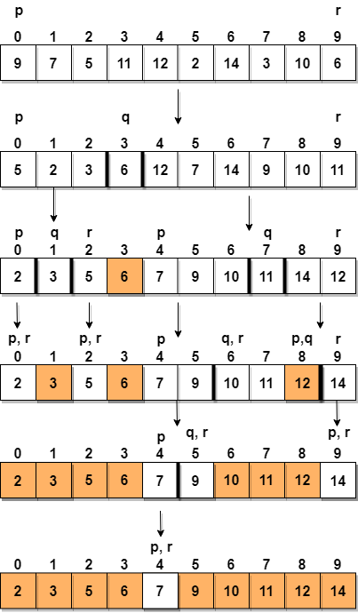

**Step 1** − Choose the highest index value has pivot

**Step 2** − Take two variables to point left and right of the list excluding pivot

**Step 3** − left points to the low index

**Step 4** − right points to the high

**Step 5** − while value at left is less than pivot move right

**Step 6** − while value at right is greater than pivot move left

**Step 7** − if both step 5 and step 6 does not match swap left and right

**Step 8** − if left ≥ right, the point where they met is new pivot

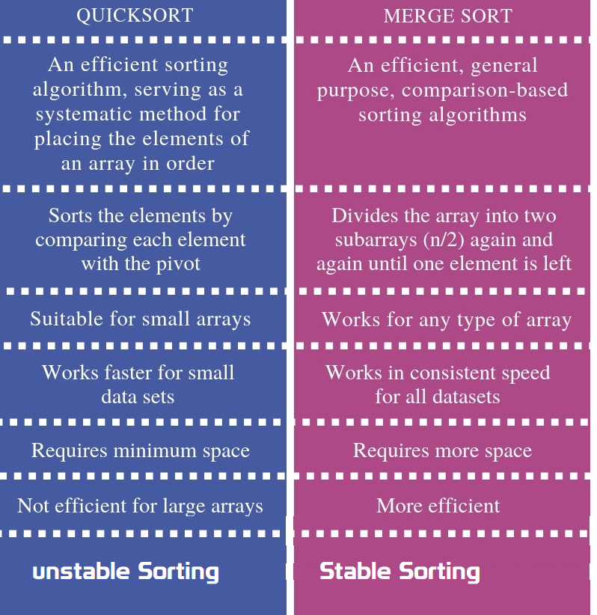

Stable vs Unstable Algorithm

Suppose you need to sort following key-value pairs in the increasing order of keys:  
  
INPUT: (4,5), (3, 2) (4, 3) (5,4) (6,4)  
  
Now, there is two possible solution for the two pairs where the key is the same i.e. (4,5) and (4,3) as shown below:  
  
OUTPUT1: (3, 2),  (4, 5),  (4,3),  (5,4),  (6,4)  
OUTPUT2: (3, 2),  (4, 3),  (4,5),  (5,4),  (6,4)  
  
The sorting algorithm which will produce the first output will be known as stable sorting algorithm because the original order of equal keys are maintained, you can see that (4, 5) comes before (4,3) in the sorted order, which was the original order i.e. in the given input, (4, 5) comes before (4,3) .  
  
On the other hand, the algorithm which produces second output will know as an unstable sorting algorithm because the order of objects with the same key is not maintained in the sorted order. You can see that in the second output, the (4,3) comes before (4,5) which was not the case in the original input.

Some examples of

* **stable algorithms** **are Merge Sort,**[**Insertion Sort**](http://www.java67.com/2014/09/insertion-sort-in-java-with-example.html)**,**[**Bubble Sort**](http://javarevisited.blogspot.com/2014/08/bubble-sort-algorithm-in-java-with.html)**, and Binary Tree Sort**.
* **unstable algorithms** are  **[QuickSort](http://javarevisited.blogspot.com/2014/08/quicksort-sorting-algorithm-in-java-in-place-example.html" \t "_blank), Heap Sort, and Selection sort**

If you remember, Collections.sort() method from Java Collection framework uses iterative merge sort which is a stable algorithm.

How much time does it take to retrieve an element if stored in HashMap, Binary tree, and a Linked list? how it change if you have millions of records?

* **HashMap** it takes**O(1)** time,because it uses hashing to get element location.
* **Binary tree** it takes **O(logN)** where N is a number of nodes in the tree
* **LinkedList** it takes **O(n)** time where n is a number of element in the list.

Millions of records don't affect the performance if the data structure is working as expected e.g. HashMap has no or relatively less number of collision or binary tree is balanced. If that's not the case then their performance degrades as a number of records grows.

### can we insert elements in middle of LinkedList?

ListIterator add, remove is possible ?

* Can iterate over an Collection
* Remove operation allowed
* Add operation allowed
* Backward direction allowed

|  |  |
| --- | --- |
| **Public ListIterator listIterator()**  Ex. ListIterator = l.listIterator ()  **boolean hasPrevious()**  **boolean hasNext()** | add(E e)  nextIndex()  previous()  previousIndex()  remove()  next()  set(E e) |

public class Test {

public static void main(String[] args) throws InterruptedException {

LinkedList l = new LinkedList<>();

for (int i = 0; i < 10; i++) {

l.add(i);

}

System.*out*.println(l);

ListIterator iterator = l.listIterator();

while(iterator.hasNext())

{

int next = (int) iterator.next();

System.*out*.println(next);

if(next>5)

l.add(10);

}

System.*out*.println(l);

}

}

[0, 1, 2, 3, 4, 5, 6, 7, 8, 9]

0

1

2

3

4

5

6

Exception in thread "main" java.util.ConcurrentModificationException

at java.util.LinkedList$ListItr.checkForComodification(LinkedList.java:966)

at java.util.LinkedList$ListItr.next(LinkedList.java:888)

at Test.main(Test.java:27)

# Servlets

What is JSESSIONID in J2EE Web application - JSP Servlet?

HTTP protocol and Web Servers are stateless, what it means is that for web server every request is a new request to process and they can’t identify if it’s coming from client that has been sending request previously.

**Session** is a conversional state between client and server and it can consist of multiple request and response between client and server. Since HTTP and Web Server both are stateless, the only way to maintain a session is when some unique information about the session (session id) is passed between server and client in every request and response.

When we use HttpServletRequest getSession() method and it creates a new request, it creates the new HttpSession object and also add a Cookie to the response object with name JSESSIONID and value as session id. This cookie is used to identify the HttpSession object in further requests from client. If the cookies are disabled at client side and we are using URL rewriting then this method uses the jsessionid value from the request URL to find the corresponding session. JSESSIONID cookie is used for session tracking, so we should not use it for our application purposes to avoid any session related issues.

How servlet session will work, if Cookies disabled?

In a web app, when user logs in, a HttpSession is created using HttpSession s = request.getSession(true); This creates a cookie with jsessionid on the browser. But if cookies are disabled on browser, How can i proceed with login?

If Cookies are disabled. You should be using URL Rewriting mechanism for Session tracking

Can you describe the difference between valid and well-formed XML?

A well-formed XML is the one which has **root element and all tags are closed properly**, attributes are defined properly, their value is also quoted properly.

On another hand, a valid XML is the one which **can be validated against an XSD file or schema**. So it's possible for an XML to be well-formed but not valid because they contain tags which may not be allowed by their schema.

Maven& Ant build for diffrenrt enviroments using properties

Ant

Ant’s build file, called **build.xml** should reside in the base directory of the project. However ***there is no restriction on the file name or its location***. You are free to use other file names or save the build file in some other location

<?xml version = "1.0"?>

<project name = "Hello World Project" default = "info">

<target name = "info">

<echo>Hello World - Welcome to Apache Ant!</echo>

</target>

</project>

<project name="Sample Build Script" default="init" basedir=".">

<property environment="env" />

<!-- \*\*\*\*\* COMMAND LINE ARGUMENTS DEMOED HERE -->

<property name="build\_type" value= "${env.build\_type}"/>

<property name="version" value="${env.version}"/>

<!-- \*\*\*\*\* END OF COMMAND LINE ARG \*\*\*\* -->

<property name="src.dir" value="${basedir}/source"/>

<property name="build.classes.dir" value="${basedir}/classes"/>

<property name="project.name" value="myproject"/>

<target name="make-war" depends="compile-servlet">

<delete file="${build.classes.dir}/war/${project.name}.war"/>

<war destfile="${build.classes.dir}/war/${project.name}.war" webxml="${src.dir}/WEB-INF/web.xml">

<webinf dir="${src.dir}/WEB-INF" />

<fileset dir="${src.dir}/html">

<include name="\*.html" />

</fileset>

<classes dir="${build.classes.dir}">

<include name="/my/package/\*.\*"/>

</classes>

<lib dir="/some/lib/loc">

<include name="some-lib.jar"/>

</lib>

</war>

</target>

<target name="init" >

<echo message="Using Source directory=${src.dir}" />

<echo message="Using Build-Classes directory=${build.classes.dir}" />

<!-- \*\*\*\* VERIFY COMMAND LINE ARGS HERE \*\*\*\*\* -->

<echo message="Build Type=${build\_type}" />

<echo message="Build Version =${version}" />

<!-- \*\*\* END VERIFY COMMAND LINE ARGUMENTS -->

</target>

</project>

Maven – pom.xml

I have a web app in Maven, with the default directory structure. No problem there. The default directory structure has some property files that point to my localhost database.

Currently I create an Ant script to create different war files - one for production and one for development, using these commands:

ant deploy-dev

ant deploy-prod

ant deploy-sit

ant deploy-uat

I prefer use maven profiles for this situation. For example we have directory structure:

src/main/resources

|

+- local

| |

| `- specific.properties

+- dev

|

`- specific.properties

In pom.xml define two profiles:

<profiles>

<profile>

<id>local</id>

<activation>

<activeByDefault>true</activeByDefault>

</activation>

<build>

<resources>

<resource>

<directory>src/main/resources/local</directory>

</resource>

</resources>

</build>

</profile>

<profile>

<id>dev</id>

<build>

<resources>

<resource>

<directory>src/main/resources/dev</directory>

</resource>

</resources>

</build>

</profile>

</profiles>

To activate this you would type this on the command line:

1. mvn groupId:artifactId:goal -Denvironment=local

# Web Services

What is purpose of different HTTP Request Types in RESTful Web Service?

* **GET** request on /employee/101, you can retrieve details of that user.
* **POST** on employe/102 would create a new user with employee id 102,
* **PUT** request type on /employee/101 can be used to update details of employee with id 101.
* **DELETE** method on /employee/101 can be used to remove data for that id.

By the way, in the case of PUT and POST method representation would be in the **request body**

# Spring MVC

Do you need spring-mvc.jar in your classpath or is it part of spring-core? (answer)

The spring-mvc.jar is not part of spring-core, which means if you want to use Spring MVC framework in your Java project, you must include spring-mvc.jar in your application's classpath. In Java web application, spring-mvc.jar is usually placed inside /WEB-INF/lib folder.

What is the DispatcherServlet and what is it used for? ([answer](http://www.java67.com/2017/06/what-is-use-of-dispatcherservlet-in-spring-mvc.html))

The DispatcherServlet is an implementation of Front Controller design pattern which handles all incoming web request to a Spring MVC application. A Front Controller pattern is a common pattern in web applications whose job is to receive all request and route it to different components of application for actual processing.  
  
In case of Spring MVC, DispatcherServlet route web requests to Spring MVC controllers.  
  
In Spring MVC, DispatcherServlet is used for finding the correct Controler to process a request, which it does with the help of handler mapping e.g. @RequestMapping annotation.  
  
It is also responsible for delegating logical view name to ViewResolver and then sending the rendered response to the client.

Is the DispatcherServlet instantiated via an application context? ([answer](http://javarevisited.blogspot.sg/2017/09/dispatcherservlet-of-spring-mvc-10-points-to-remember.html))  
No, DispatcherServlet is instantiated by Servlet containers like Tomcat or Jetty. You must define DispatcherServlet into the web.xml file

What is the root application context in Spring MVC? How is it loaded? ([answer](https://javarevisited.blogspot.com/2012/11/difference-between-beanfactory-vs-applicationcontext-spring-framework.html#axzz5N1cdCqrn))

In Spring MVC, the context loaded using ContextLoaderListener is called the "root" application context which belongs to the whole application while the one initialized using DispatcherServlet is actually specific to that servlet.  
  
Technically, Spring MVC allows multiple DispatcherServlet in a Spring MVC web application and so multiple such contexts each specific for respective servlet but having same root context may exist.

The ContextLoaderListener is configured in web.xml as listener and you put that inside a tag as shwon below:  
<listener>  
<listener-class>  
org.springframework.web.context.ContextLoaderListener  
</listener-class>  
</listener>  
  
When the Spring MVC web application is deployed, Servlet container created an instance of ContextLoaderListener class which loads the Spring's WebApplicationContext

**What is the @Controller annotation used for? How can you create a controller without an annotation? (**[**answer**](https://javarevisited.blogspot.com/2017/08/difference-between-restcontroller-and-controller-annotations-spring-mvc-rest.html)**)**

The @Controller is a Spring MVC annotation to define Controller but in reality, it's just a stereotype annotation. You can even create a controller without @Controller by annotating the Spring MVC Controller classes using @Component annotation. The real job of request mapping to handler method is done using @RequestMapping annotation.

How is an incoming request mapped to a controller and mapped to a method? ([answer](http://javarevisited.blogspot.com/2017/06/how-spring-mvc-framework-works-web-flow.html))

Sometimes this question is also asked How does DispatcherServlet knows which Controller should process the request? Well, the answer lies in something called handler mappings.  
  
Spring uses handler mappings to associate controllers with requests, two of the commonly used handler mappings are BeanNameUrlHandlerMapping and SimpleUrlHandlerMapping.  
  
In BeanNameUrlHandlerMapping, when the request url matches the name of the bean, the class in the bean definition is the controller that will handle the request.  
  
On the other hand, In SimpleUrlHandlerMapping, the mapping is more explicit. You can specify the number of URLs and each URL can be explicitly associated with a controller.  
  
Btw, if you are using annotations to configure Spring MVC, which you should then @RequestMapping annotations is used to map an incoming request to a controller and a handler method.

What are some of the valid return types of a controller method? (answer)

There are many return types are available for a controller method in Spring MVC which is annotated by @RequestMapping inside the controller. Some of the popular ones are:

1. **String**
2. **void**
3. **View**
4. **ModelAndView (Class)**
5. **Model (Interface)**
6. **Map**
7. **HttpEntity<?> or ResponseEntity<?>**
8. **HttpHeaders**

What is the Model? (answer)

Model is a reference to encapsulate data or output for rendering. Model is always created and passed to the view in Spring MVC. If a mapped controller method has Model as a method parameter, then a model instance is automatically injected by Spring framework to that method.  
  
Any attributes set on the injected model are preserved and passed to the View. Here is an example of using Model in Spring MVC:

public String personDetail(Model model) {

...

model.addAttribute("name", "Joe");

...

}

What is the purpose of the session scope? ([answer](https://javarevisited.blogspot.com/2012/05/what-is-bean-scope-in-spring-mvc.html#axzz5IZi1jCsQ))

The purpose of the session scope is to create an instance of the bean for an HTTP Session. This means the same bean can serve multiple requests if it is scoped in session.

You can define the scope of a Spring bean using scope attribute or @Scope annotation in Spring MVC application.

What is the default scope in the web context? ([answer](http://javarevisited.blogspot.sg/2012/05/what-is-bean-scope-in-spring-mvc.html))

The **singleton** scope is the default scope for a Spring bean even in the web context.

The other three Web context-aware scopes are a **request, session, and global-session,** which are only available in a web application aware ApplicationContext object.

What are safe REST operations? (answer)

REST API uses HTTP methods to perform operations. Some of the HTTP operations which doesn't modify the resource at the server is known as safe operations e.g**. GET and HEAD**.

On the other hand, [**PUT**](http://javarevisited.blogspot.sg/2016/10/difference-between-put-and-post-in-restful-web-service.html)**, POST, and DELETE** **are unsafe** because they modify the resource on the server

What are the advantages of the RestTemplate? ([answer](http://javarevisited.blogspot.sg/2017/02/how-to-consume-json-from-restful-web-services-Spring-RESTTemplate-Example.html))

The **RestTemplate** class is an implementation of Template method pattern in Spring framework. Similar to other popular template classes e.g. **JdbcTemplate** or **JmsTempalte**, it also simplifies the interaction with RESTful Web Services on the client side.i mean we can create client class to test webservice manulay using java.

You can use it to consume a RESTful Web Servicer very easily as shown in this example.

public class App implements CommandLineRunner {

private static final Logger *log* = LoggerFactory.getLogger(App.class);

public static void main(String args[]) {

SpringApplication.run(App.class);

}

public void run(String... args) throws Exception {

RestTemplate restTemplate = new RestTemplate();

Response response = restTemplate.getForObject("localhost:9090/student/getall",

Response.class);

*log*.info("==== RESTful API Response using Spring RESTTemplate START =======");

*log*.info(response.toString());

*log*.info("==== RESTful API Response using Spring RESTTemplate END =======");

}

}

What is an HttpMessageConverter in Spring REST? (answer)

An HttpMessageConverter is a [Strategy interface](http://www.java67.com/2014/12/strategy-pattern-in-java-with-example.html) that specifies a converter that can convert from and to HTTP requests and responses. Spring REST uses this interface to convert HTTP response to various formats e.g. **JSON or XML.**  
Each HttpMessageConverter implementation has one or several MIME Types associated with it. Spring uses the "**Accept**" header to determine the content type client is expecting.  
  
It will then try to find a registered HTTPMessageConverter that is capable of handling that specific content-type and use it to convert the response into that format before sending to the client.

**to create a custom implementation of HttpMessageConverter to support a new type of request/responses,**   
You just need to create an implementation of **AbstractHttpMessageConverter** and register it using the WebMvcConfigurerAdapter#extendMessageConverters() method with the classes which generate a new type of request/response.

Is @Controller a stereotype? Is @RestController a stereotype? ([answer](http://javarevisited.blogspot.sg/2017/08/difference-between-restcontroller-and-controller-annotations-spring-mvc-rest.html))

Yes, both @Controller and @RestController are stereotypes. The @Controller is actually a specialization of Spring's @Component stereotype annotation. This means that class annotated with @Controller will also be automatically be detected by Spring container as part of container's component scanning process.  
  
And, @RestController is a specialization of @Controller for RESTful web service. It not only combines @ResponseBody and @Controller annotation but also gives more meaning to your controller class to clearly indicate **that it deals with RESTful requests.**  
  
Spring Framework may also use this annotation to provide some more useful features related to REST API development in future.

Where do you need @EnableWebMVC? (answer)

The @EnableWebMvc annotation is required to enable Spring MVC when Java configuration is used to configure Spring MVC instead of XML. It is equivalent to <mvc: annotation-driven>  in XML configuration.  
  
It enables support for @Controller-annotated classes that use @RequestMapping to map incoming requests to handler methods.

**When do you need @ResponseStatus annotation in Spring MVC?**([answer](http://javarevisited.blogspot.sg/2018/01/7-reasons-for-using-spring-to-develop-RESTful-web-service.html#axzz55a8rTeu7))

A good questions for 3 to 5 years experienced spring developers. The @ResponseStatus annotation is required during error handling in Spring MVC and REST. Normally when an error or exception is thrown at server side, web server return a blanket HTTP status code 500 - Internal server error.  
  
This may work for a human user but not for REST clients. You need to send them proper status code e.g. 404 if the resource is not found. That's where you can use @ResponseStatus annotation, which allows you to send custom HTTP status code along with proper error message in case of Exception.

For example, if you are writing a RESTful Web Service for a library which provides book information then you can use @ResponseStatus to create Exception which returns HTTP response code 404 when a book is not found instead of Internal Server Error (500), as shown below:

@ResponseStatus(value=HttpStatus.NOT\_FOUND, reason="No such Book") // 404

public class BookNotFoundException extends RuntimeException {

// ...

}

If this Exception is thrown from any handler method then HTTP error code 404 with reason "No such Book" will be returned to the client.

Is REST secure? What can you do to secure it?

REST is normally not secure but you can secure it by using Spring security.  
  
At the very least you can enable HTTP basic authentication by using HTTP in your Spring security configuration file. Similarly, you can expose your REST API using[HTTPS](http://javarevisited.blogspot.sg/2013/07/how-ssl-https-and-certificates-works-in-java-web-application.html) if the underlying server supports HTTPS.

[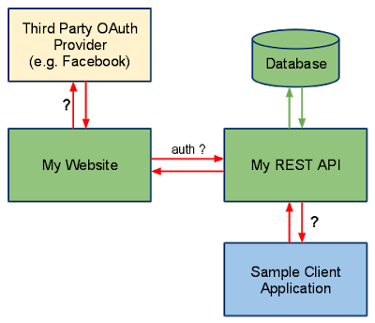](http://javarevisited.blogspot.sg/2018/01/how-to-enable-http-basic-authentication-spring-security-java-xml-configuration.html)

# SQL

Write SQL query to find second highest salary in employee table?

SELECT MAX(Salary) FROM Employee WHERE Salary NOT IN (SELECT MAX(Salary) FROM Employee)

This query first finds maximum salary and then exclude that from the list and again finds maximum salary. Obviously second time, it would be second highest salary.

Difference between WHERE vs HAVING clause in SQL - GROUP BY Comparison with Example

*main difference between WHERE and HAVING clause in SQL* is that, condition specified in WHERE clause is used while fetching data (rows) from table, on the other hand HAVING clause is later used to filter summarized data or grouped data.

**SELECT** \* **FROM** Employee;

|  |  |  |  |  |
| --- | --- | --- | --- | --- |
| **EMP\_ID** | **EMP\_NAME** | **EMP\_AGE** | **EMP\_SALARY** | **DEPT\_ID** |
| 1 | Virat | 23 | 10000 | 1 |
| 2 | Rohit | 24 | 7000 | 2 |
| 3 | Suresh | 25 | 8000 | 3 |
| 4 | Shikhar | 27 | 6000 | 1 |
| **5** | **Vijay** | **28** | **5000** | **2** |

**SELECT** \* **FROM** Department;

|  |  |
| --- | --- |
| **DEPT\_ID** | **DEPT\_NAME** |
| 1 | Accounting |
| 2 | Marketing |
| 3 | Sales |

SELECT d.DEPT\_NAME, count(e.EMP\_NAME) as NUM\_EMPLOYEE, avg(e.EMP\_SALARY) as AVG\_SALARY

FROM Employee e,Department d

WHERE e.DEPT\_ID=d.DEPT\_ID

AND EMP\_SALARY > 5000

GROUP BY d.DEPT\_NAME;

|  |  |  |
| --- | --- | --- |
| **DEPT\_NAME** | **NUM\_EMPLOYEE** | **AVG\_SALARY** |
| Accounting | 1 | 8000 |
| Marketing | 1 | 7000 |
| Sales | 2 | 8000 |

From the number of employee (NUM\_EMPLOYEE) column you can see that only Vijay who work for Marketing department is not included in result set because his earning 5000. This example shows that, condition in WHERE clause is used to filter rows before you aggregate them.

SELECT d.DEPT\_NAME, count(e.EMP\_NAME) as NUM\_EMPLOYEE, avg(e.EMP\_SALARY) asAVG\_SALARY

FROM Employee e,Department d

WHERE e.DEPT\_ID=d.DEPT\_ID

AND EMP\_SALARY > 5000

GROUP BY d.DEPT\_NAME

HAVING AVG\_SALARY > 7000;

|  |  |  |
| --- | --- | --- |
| **DEPT\_NAME** | **NUM\_EMPLOYEE** | **AVG\_SALARY** |
| Accounting | 1 | 8000 |
| Sales | 2 | 8000 |

then HAVING clause comes in picture for final filtering, which is clear from following query, now Marketing department is excluded because it doesn't pass condition in HAVING clause i.e AVG\_SALARY > 7000

# Coding

How to Remove Duplicates from Array?

1.Conver Array to List

2.Add List to Set(HashSet/TreeSet) allows Unique values only

public class ArrayDuplicates {

public static void main(String[] args) {

String arr[] = {"B","C","D","A","B","C","D","A","E","E"};

List list = Arrays.*asList*(arr);

HashSet h = new HashSet(list);

System.*out*.println("Hashset : "+h);

TreeSet t = new TreeSet(list);

System.*out*.println("TreeSet : "+t);

}

}

Hashset: [A, B, C, D, E]

TreeSet: [A, B, C, D, E]

How do you get the last digit of an integer?

By using **modulus operator(%),** **number % 10** returns the last digit of the number, for example,

* 2345%10 will return 5
* 567%10 will return 7.

Similarly, **division operator(/ )** can be used to get rid of the last digit of  a number e.g.

* 2345/10 will give 234
* 567/10 will return 56.

This is an important technique to know and useful to solve problems like **number palindrome or reversing numbers**

public static int reverse(int number){ //say 12345

int reverse = 0;

int remainder = 0;

int i=1;

do{

remainder = number%10; //To Get last Number

reverse = reverse\*10 + remainder; //To add places, 10, 100, 1000

number = number/10; // To remove Last Number

/\*reverse = reverse\*10 + remainder;

\* 5 = 0\*10+5

\* 54 = 5\*10 = 50+4 = 54,

\* 543 = 54\*10 = 540+3 = 543

\* \*/

System.*out*.println(i+"---> remainder: "+remainder+", reverse: "+reverse+", number: "+number);

i++;

}while(number > 0);

return reverse;

}

How to Find Missing Number on Integer Array of 1 to 100

METHOD 1(Use sum formula)  
Algorithm:

1. Get the sum of numbers

total = n\*(n+1)/2

2 Subtract all the numbers from sum and

you will get the missing number.

class Main

{

// Function to ind missing number

static int getMissingNo (int a[], int n)

{

int i, total;

total = (n+1)\*(n+2)/2;

for ( i = 0; i< n; i++)

total -= a[i];

return total;

}

/\* program to test above function \*/

public static void main(String args[])

{

int a[] = {1,2,4,5,6};

int miss = *getMissingNo*(a,5);

System.*out*.println(miss);

}

}

Write code to check a String is palindrome or not? ([solution](http://www.java67.com/2015/06/how-to-check-is-string-is-palindrome-in.html))

A palindrome is those String whose reverse is equal to the original. This can be done by using **either StringBuffer reverse()**method or by technique demonstrated in the solution here.

Write a method which will remove any given character from a String? ([solution](http://javarevisited.blogspot.sg/2015/04/how-to-remove-given-character-from.html))

you can remove a given character from String by converting it into a **char[]** array and comapare give char with each char of array, remove that & append remaiiing.

public class Test {

public static String remove(String word, char unwanted) {

StringBuilder sb = new StringBuilder();

char[] letters = word.toCharArray();

for (char c : letters) {

if (c != unwanted) {

sb.append(c);

}

}

return sb.toString();

}

public static void main(String[] args) throws InterruptedException {

System.*out*.println(*remove*("satya kaveti", 'a'));

}

}

sty kveti

Print all permutation of String? ([solution](https://javarevisited.blogspot.com/2015/08/how-to-find-all-permutations-of-string-java-example.html))

for a String of 3 characters like "xyz" has 6 possible permutations, xyz, xzy, yxz, yzx, zxy, zyx

public class Permutation {

public static void permutation(String str) {

*permutation*("", str);

}

private static void permutation(String prefix, String str) {

int n = str.length();

if (n == 0) System.*out*.println(prefix);

else {

for (int i = 0; i < n; i++)

*permutation*(prefix + str.charAt(i), str.substring(0, i) + str.substring(i+1, n));

}

}

public static void main(String args[]) {

*permutation*("XYZ");

}

}

XYZ

XZY

YXZ

YZX

ZXY

ZYX

How to check if two String Are Anagram? ([solution](http://javarevisited.blogspot.sg/2013/03/Anagram-how-to-check-if-two-string-are-anagrams-example-tutorial.html))

two String are called anagram, if they contain same characters but on different order e.g. **army** and **mary**, **stop** and **pots** etc

public class Anagram {

public static boolean Check(String word1, String word2) {

char[] charFromword1 = word1.toCharArray();

char[] charFromword2 = word2.toCharArray();

Arrays.*sort*(charFromword1);

Arrays.*sort*(charFromword2);

return Arrays.*equals*(charFromword1, charFromword2);

}

public static void main(String args[]) {

System.*out*.println(*Check*("stop", "pots"));

System.*out*.println(*Check*("army", "mary"));

}

}

true

true

Java Program to print Fibonacci Series

Fibonacci number is sum of previous two Fibonacci numbers **fn= fn-1+ fn-2**. first 10 Fibonacci numbers are 1, 1, 2, 3, 5, 8, 13, 21, 34, 55.

public class Permutation {

public static void main(String args[]) {

// input to print Fibonacci series upto how many numbers

int number = 10;

System.*out*.println("Fibonacci series upto " + number + " numbers : ");

// printing Fibonacci series upto number

for (int i = 1; i <= number; i++) {

System.*out*.print(*fibonacci*(i) + " ");

}

}

public static int fibonacci(int number) {

if (number == 1 || number == 2) {

return 1;

}

return *fibonacci*(number - 1) + *fibonacci*(number - 2); // tail recursion

}

}

Fibonacci series upto 10 numbers :

1 1 2 3 5 8 13 21 34 55

How to find the factorial of a number in Java

 the factorial of a number is calculated by formula **number\*(number -1**) till zero and since the **value of factorial zero is 1**.

public class Permutation {

public static int fact(int number){

int result = 1;

while(number != 0){

result = result\*number;

number--;

}

return result;

}

public static void main(String args[]) {

int res = *fact*(5);

System.*out*.println("Fianl Factoril is : "+res);

}

}

Fianl Factoril is : 120

Java program Armstrong numbers in the range of 0 and 9999.

An Armstrong number is a number such that the sum of its digits raised to the third power is equal to the number itself. For example, 153 is an Armstrong number, since 1\*\*3 + 5\*\*3 + 3\*\*3 = 153.

public class Permutation {

public static void main(String args[]) {

int count = 999;

int index = 0;

for (int i = 0; i < count; i++) {

if (*isArmstrongNumber*(i)) {

System.*out*.printf("Armstrong number %d: %d %n", index, i);

index++;

}

}

}

/\*\*

\* Java Method to check if given number is Armstrong Number or not

\*

\* @param number

\* @return true, if Armstrong number, false otherwise.

\*/

public static boolean isArmstrongNumber(int number) {

int sum = 0;

int copyOfInput = number;

while (copyOfInput != 0) {

int lastDigit = copyOfInput % 10;

sum += (lastDigit \* lastDigit \* lastDigit);

copyOfInput /= 10;

}

if (sum == number) {

return true;

}

return false;

}

}

Armstrong number 0: 0

Armstrong number 1: 1

Armstrong number 2: 153

Armstrong number 3: 370

Armstrong number 4: 371

Armstrong number 5: 407

Java Program to print 1 to 100 without using loop

public class Permutation {

public static void usingRecursion(int number){

if(number > 1){

*usingRecursion*(number-1);

}

System.*out*.println(number);

}

public static void main(String args[]) {

*usingRecursion*(20);

}

}

Links

<https://javarevisited.blogspot.com/2011/06/top-programming-interview-questions.html>

<https://javarevisited.blogspot.com/2017/07/top-50-java-programs-from-coding-Interviews.html>

<https://javarevisited.blogspot.com/search/label/Coding%20Interview%20Question?max-results=100>

# H R Mapping

Reason for Job Change"

I am looking for better opportunities! Both Technically & Finacially. I want to the part of Product based things, innovating / implementing some thing new instead of working with existing code.

I think this job would be a great opportunity in my career.

**Keep in Mind:**

* Tell the truth, yes! because big shots like google or microsoft sees honesty in employees.
* Be positive. Tell them what's your work there and how it's affecting you blah blah
* Tell them, I'm good at 'x' but I"m doing 'y' there.
* Put your points in polite manner.

# Reference

Interview Questions

<https://javarevisited.blogspot.com/search/label/interview%20questions?max-results=100>

Coding

<https://javarevisited.blogspot.com/2017/07/top-50-java-programs-from-coding-Interviews.html>

<https://javarevisited.blogspot.com/search/label/Coding%20Interview%20Question?max-results=100>